**RETAIL EDGE**

**A PROJECT REPORT**

**for**

**Mini Project-II(ID201B)**

**Session (2024-25)**

**Submitted by**

**SHANTANU YADAV**

**( 202410116100193 )**

**SHIVAM CHATURVEDI**

**( 202410116100198 )**

**SONAM DOBRIYAL**

**( 202410116100210 )**

**VINEET KUMAR**

**( 202410116100246 )**

**Submitted in partial fulfillment of the**

**Requirements for the Degree of**

**MASTER OF COMPUTER APPLICATION**

**Under the Supervision of**

**Ms. Divya Singhal**

### Assistant Professor

**Submitted to**

**Department Of Computer Applications**

**KIET Group of Institutions, Ghaziabad**

**Uttar Pradesh-201206**

**(MAY- 2024)**

**CERTIFICATE**

Certified that **Shantanu Yadav (202410116100193), Sonam Dobriyal (202410116100210), Shivam Chaturvedi (202410116100198), Vineet Kumar (202410116100246)** has/ have carried out the project work having “**RETAIL EDGE**.” (**Mini Project-I, K24MCA18P**) for **Master of Computer Application** from Dr. A.P.J. Abdul Kalam Technical University (AKTU**)** (formerly UPTU), Lucknow under my supervision. The project report embodies original work, and studies are carried out by the student himself/herself and the contents of the project report do not form the basis for the award of any other degree to the candidate or to anybody else from this or any other University/Institution.

**Dr. Akash Rajak**

**Dean**

**Department of Computer Applications**

**KIET Group of Institutions, Ghaziabad**

**Ms. Shruti Aggrawal**

**Assistant Professor**

**Department of Computer Applications**

**KIET Group of Institutions, Ghaziabad**

**RETAIL EDGE**

**ABSTRACT**

The "Retail Edge" project aims to revolutionize the traditional shopping experience by introducing a self-checkout app designed to minimize queues and enhance the overall convenience of shopping. This innovative application empowers customers to independently scan, bag, and pay for their items using their smartphones, eliminating the need for long waits at checkout counters. By streamlining the purchasing process, "Retail Edge" addresses one of the most common pain points in retail: time-consuming lines. The app also improves store efficiency, reduces the need for staff intervention, and provides a more enjoyable, friction-less shopping experience for customers. Ultimately, "Retail Edge" transforms mundane shopping routines into a smoother, faster, and more satisfying process, enabling retailers to offer a modern and customer-eccentric solution that aligns with today’s fast-paced lifestyle.

**ACKNOWLEDGEMENTS**

Success in life is never attained single-handedly. My deepest gratitude goes to my project supervisor, **Ms. Shruti Aggrawal** for her guidance, help, and encouragement throughout my project work. Their enlightening ideas, comments, and suggestions.

Words are not enough to express my gratitude to Dr. Akash Rajak, Professor and Dean, Department of Computer Applications, for his insightful comments and administrative help on various occasions.

Fortunately, I have many understanding friends, who have helped me a lot on many critical conditions.

Finally, my sincere thanks go to my family members and all those who have directly and indirectly provided me with moral support and other kind of help. Without their support, completion of this work would not have been possible in time. They keep my life filled with enjoyment and happiness.

**Shantanu Yadav**

**Shivam Chaturvedi**

**Sonam Dobriyal**

**Vineet Kumar**

**TABLE OF CONTENT**

Certificate………………………………………………… i

Abstract…………………………………………………... ii

Acknowledgement……………………………………….. iii

Table of Contents………………………………………… iv

1. **Introduction**

**1.1 Overview……………………………………………………… 1**  
1.2 **Objectives of RetailEdge……………………………………... 6**  
1.3 **Scope of the Project…………………………………………... 8**  
1.4 **Methodology Overview………………………………………. 9**  
1.5 **Document Structure…………………………………………... 10**

1. **Feasibility Study**

2.1 **Technical Feasibility…………………………………………. 13**  
2.2 **Operational Feasibility……………………………………….. 14**  
2.3 **Economic Feasibility ……………………………………….... 15**  
2.4 **Legal Feasibility……………………………………………… 16**

1. **Project Objective…………………………………………. 19**
2. **System Design and Requirements**
   1. **Hardware Requirements………………………………………… 22**
   2. **Software Requirements…………………………………………. 23**
   3. **Deployment Requirements……………………………………… 24**
3. **Project Flow………………………………………………….. 25**
4. **Project Outcomes ……………………………………………. 31**
5. **References……………………………………………………. 37**

**Chapter 1**

**Introduction**

**1.1 Overview**

The Internet of Things (IoT) is transforming the retail industry by enabling automation, enhancing customer experiences, and optimizing operations. As retailers face increasing competition and evolving consumer demands, IoT-driven automation has become a crucial factor in achieving efficiency and growth.

The RetailEdge project marks a significant stride towards the digital transformation of the retail sector. It aims to provide a comprehensive solution to enhance customer experience and operational efficiency in supermarkets, grocery stores, and canteens. By integrating features such as automated billing, inventory management, and seamless payment processing, RetailEdge bridges the gap between traditional retail methods and modern digital practices.

The project is motivated by the need to revolutionize the retail industry using the latest technological innovations. It addresses customer convenience, operational efficiency, and technological integration, ensuring a quick, hassle-free shopping experience and reducing manual processes. RetailEdge utilizes IoT devices, cloud computing, and advanced analytics to create an interconnected ecosystem, supporting real-time data processing and decision-making.

The potential impact on the retail industry includes enhanced customer experience, improved inventory management, operational cost reduction, data-driven insights, and sustainability. RetailEdge automates key processes, provides real-time data, and offers valuable insights into customer behavior and sales trends. This leads to higher customer satisfaction, reduced operational costs, and better alignment with market demands. RetailEdge stands as a game-changer, redefining how retailers and customers interact in a digitally driven world.

**Industry Context**

The retail industry, a vital part of the global economy, is perpetually evolving to cater to shifting consumer preferences and technological advancements. Traditional retail models are being redefined to offer faster, more convenient shopping experiences, driven by digital technologies. RetailEdge is positioned at the forefront of this transformation, addressing inefficiencies in conventional retail systems by leveraging emerging technologies. The project capitalizes on the growing trend of self-service kiosks, automated inventory tracking, and digital payment gateways.

By integrating these advanced features, RetailEdge provides a comprehensive solution for retailers, enhancing operational efficiency and customer satisfaction. This initiative not only aligns with the industry’s digitalization trend but also sets a new benchmark for retail excellence. With its holistic approach, RetailEdge aims to revolutionize the shopping experience, making it more Efficient, enjoyable, and seamless for both customers and retailers. The project's emphasis on technology integration ensures that it is well-equipped to meet the demands of modern consumers while driving the future of retail towards a more connected and intelligent ecosystem.

**Market Need and Analysis**

The demand for faster checkout processes, accurate billing systems, and efficient inventory management has never been higher. RetailEdge is designed to meet these demands by eliminating the bottlenecks associated with manual retail operations. Market analysis reveals that over 70% of customers prefer stores with self-service options, and more than 60% of retailers struggle with managing inventory levels effectively. RetailEdge addresses these challenges by introducing innovative features such as real-time inventory updates and user-friendly interfaces.

With real-time inventory updates, retailers can maintain accurate stock levels, prevent overstocking or stock-outs, and make informed decisions based on current data. This not only enhances operational efficiency but also ensures that customers always find what

they need on the shelves. The user-friendly interfaces of RetailEdge simplify the shopping experience, making it easier for customers to navigate, select, and purchase products.

By integrating automated billing and seamless payment processing, RetailEdge reduces the time customers spend in checkout lines, thereby improving overall satisfaction. These features collectively enhance both the retailer's and the customer's experience, positioning RetailEdge as a comprehensive solution that bridges the gap between traditional retail methods and modern digital practices, driving the retail industry towards a more efficient and customer-eccentric future.

**Problem Statement**

Traditional retail systems are plagued by inefficiencies that significantly affect both customer satisfaction and business profitability. Common issues include manual errors in billing, prolonged checkout times, and inaccurate inventory tracking. These inefficiencies often result in frustrating shopping experiences for customers and financial losses for businesses due to lost sales and increased labor costs.

Manual billing processes are prone to errors, leading to incorrect charges and dissatisfied customers. Long checkout lines deter shoppers and reduce store turnover. Inaccurate inventory tracking means that popular items may be out of stock, while less desired items occupy valuable shelf space. These challenges are compounded by the need for real-time data to make informed decisions.

RetailEdge aims to address these problems by offering a comprehensive, automated solution that integrates key aspects of retail operations into a single, cohesive platform. By utilizing advanced technologies such as IoT devices, automated billing systems, and real-time inventory management, RetailEdge reduces manual errors, speeds up the checkout process, and ensures accurate inventory tracking. This results in improved customer experiences, increased operational efficiency, and enhanced profitability for retailers. Through its innovative approach, RetailEdge bridges the gap between traditional retail practices and modern digital advancements, driving the industry towards a more efficient and customer-centric future.

**Challenges in Traditional Retail Systems**

**Manual Billing Errors:** Human errors in manual billing often result in revenue loss and customer dissatisfaction. When billing is done manually, the likelihood of mistakes increases, leading to incorrect charges and unhappy customers.

**Long Checkout Queues:** Prolonged waiting times at checkout counters deter customers and reduce sales opportunities. Lengthy queues can frustrate shoppers, causing them to abandon their purchases or avoid the store altogether.

**Inefficient Inventory Management:** The lack of real-time inventory tracking results in stockouts or overstocking, both of which are costly for retailers. Without accurate inventory management, stores may run out of popular items or hold excess stock, leading to increased expenses and lost sales.

Addressing these challenges, RetailEdge aims to enhance operational efficiency and customer satisfaction. By integrating automated billing, real-time inventory tracking, and seamless payment processing, RetailEdge provides a comprehensive solution that mitigates these issues, resulting in a more efficient and enjoyable shopping experience for both customers and retailers.

**1.2 Objectives of RetailEdge**

**Core Objectives**

The primary objectives of RetailEdge are focused on revolutionizing the retail experience:

**Enhancing Customer Satisfaction:** RetailEdge aims to provide a quick and hassle-free checkout experience, ensuring customers spend less time waiting and more time enjoying their shopping experience.

**Improving Operational Efficiency:** By implementing automated inventory management and billing systems, RetailEdge significantly reduces the time and effort required to manage these processes manually. This automation helps in streamlining operations, making them more efficient.

**Reducing Errors:** Minimizing human intervention in critical retail operations such as billing and inventory management reduces the likelihood of errors. This leads to more accurate transactions and inventory records, fostering trust and reliability.

**Secondary Objectives**

In addition to its core objectives, RetailEdge aims to achieve the following secondary goals:

**Provide Actionable Insights:** Through advanced data analytics, RetailEdge provides retailers with valuable insights into customer behavior, sales trends, and inventory needs. This data-driven approach helps retailers make informed decisions that enhance performance and profitability.

**Enable Scalability:** RetailEdge is designed to support scalability, allowing it to be implemented across multiple stores and various retail formats. This flexibility ensures that retailers of all sizes can benefit from its features.

**Promote Digital Payments:** By facilitating the adoption of digital payments, RetailEdge enhances transaction security and offers a more convenient payment process for customers, aligning with modern payment preferences.

**1.3 Scope of the Project**

The scope of RetailEdge encompasses the development of a robust web-based application designed specifically for supermarkets, grocery stores, and canteens. This application aims to streamline various aspects of retail operations, enhancing both customer experience and operational efficiency.

Key features of the application include:

**Automated Billing System:** This feature allows customers to self-checkout with ease, reducing wait times and enhancing convenience. The system automatically calculates the total bill, minimizing errors associated with manual billing.

**Inventory Management Module:** This module provides real-time stock updates, helping retailers avoid shortages or overstocking. By maintaining accurate inventory levels, retailers can ensure that popular products are always available while minimizing waste.

**Payment Integration:** The application supports multiple payment methods, including digital wallets and UPI, catering to diverse customer preferences. This flexibility ensures a smooth and secure payment process, enhancing overall satisfaction.

**Multi-Platform Accessibility:** RetailEdge is designed to be accessible across various devices, including desktops, tablets, and smartphones. This multi-platform support ensures that both customers and staff can use the system conveniently, regardless of their device. RetailEdge aims to revolutionize the retail industry by integrating these advanced features into a single, user-friendly platform.

**1.4 Methodology Overview**

The **RetailEdge** project follows the Software Development Life Cycle (SDLC) methodology, divided into phases:

**Requirement Analysis:** Gathering input from stakeholders to identify core functionalities.

**System Design:** Creating wire-frames and prototypes for the application.

**Implementation:** Developing the application using Spring Boot for back-end functionality and React for the front-end interface.

**Testing:** Conducting rigorous testing to ensure functionality and performance.

**Deployment:** Deploying the application across retail environments for real-world usage.

**Maintenance:** Providing ongoing support to address issues and incorporate feedback.

**1.5 Document Structure**

The structure of this document is designed to provide a comprehensive overview of the RetailEdge project and its development process. Each section addresses a critical aspect of the project, ensuring a clear and thorough understanding for the reader:

**Introduction:** This section provides an overview of the RetailEdge project, outlining its objectives and scope. It sets the stage for the detailed discussions that follow, highlighting the project's significance in the retail industry.

**Feasibility Study:** This section examines the viability of the RetailEdge project by analyzing market demands, technical challenges, and potential solutions. It also reviews existing solutions in the market, identifying gaps that RetailEdge aims to fill.

**Hardware and Software Requirements:** This section details the technical specifications needed for the development and deployment of RetailEdge. It includes the necessary hardware components and software tools, ensuring a seamless integration and operation.

**Project Flow/Research Methodology:** This section explains the step-by-step approach to building RetailEdge. It covers the planning, design, implementation, and testing phases, providing a clear road-map for the project.

**Project Outcome:** This section summarizes the results of the RetailEdge project, discussing its impact on the retail industry. It also outlines potential future enhancements to further improve the system.

**References/Bibliography:** This section lists the sources consulted during the project, providing a foundation for the research and development of RetailEdge.

**Chapter 2**

**Feasibility Study**

The feasibility study for RetailEdge is designed to comprehensively evaluate the project's potential across several key dimensions to ensure successful development and implementation:

**Technical Feasibility:** This objective focuses on assessing whether the project is technically feasible to develop and deploy. It involves evaluating the chosen technology stack, system architecture, and integration capabilities. This includes examining whether the necessary technical resources and expertise are available, and if the technology can support the project's requirements. The study will also consider the scalability, security, and performance of the proposed solution to ensure it can handle the expected load and protect user data effectively.

**Operational Feasibility:** This objective aims to examine the operational requirements and determine if the project can meet the needs of its users. It involves evaluating how the system will function in a real-world retail environment, its ease of use, and the training requirements for both staff and customers. The study will assess whether the system can integrate smoothly with existing retail processes, reduce operational inefficiencies, and enhance the overall shopping experience for customers. It will also consider the availability of support and maintenance resources to ensure the system remains functional and up-to-date.

**Economic Feasibility:** This objective involves analyzing the economic factors related to the project, including development costs, market demand, and revenue generation. The study will conduct a detailed cost-benefit analysis to determine the financial viability of the project. It will assess the initial investment required for development and deployment, as well as ongoing operational costs. Additionally, the study will evaluate potential revenue streams, such as subscription fees from store owners, transaction fees on payments made through the system, and partnerships with third-party vendors. The goal is to ensure that the project offers a positive return on investment and contributes to the financial sustainability of the business.

**Legal Feasibility:** This objective focuses on reviewing the legal and regulatory considerations related to the project, particularly those concerning data protection and financial transactions. The study will ensure that the system complies with relevant laws and regulations, such as the General Data Protection Regulation (GDPR) for users in the EU and other applicable data protection laws. It will also review compliance with Payment Card Industry Data Security Standard (PCI DSS) requirements to ensure secure processing of payment information. Furthermore, the study will consider local tax laws, reporting requirements, and other legal obligations in the regions where the app will be deployed. Ensuring legal compliance is crucial to protect both the business and its customers and to prevent potential legal issues that could arise from non-compliance.

By thoroughly examining these objectives, the feasibility study aims to provide a clear understanding of the project's potential challenges and benefits, thereby guiding informed decision-making for the successful implementation of RetailEdge.

### 2.1 Technical Feasibility

The technical feasibility of the RetailEdge project hinges on the utilization of a robust and modern technology stack that ensures scalability, security, and performance.

**Technology Stack:**

**Front-end Development:** The front-end will be developed using HTML5, CSS3, JavaScript, along with frameworks like React or Angular and Bootstrap. These technologies ensure the creation of responsive and user-friendly interfaces that provide an optimal user experience across various devices.

**Back-end Development:** For the back-end, Spring Boot will be employed. This powerful framework facilitates the development of robust back-end logic, APIs, and seamless system integration, ensuring reliable and efficient performance.

**Database:** MySQL or PostgreSQL will be used for database management. These relational databases are ideal for managing product, user, and transaction data, offering strong support for data integrity and reliability.

**Payment Integration:** The integration of Stripe and PayPal will provide secure and reliable payment processing, catering to diverse payment preferences and ensuring secure transactions.

**Cloud Hosting:** The application will be hosted on scalable cloud platforms such as AWS or Google Cloud. These platforms offer high availability, scalability, and robust security features to support the application’s infrastructure needs.

**Authentication & Security:** JWT (JSON Web Tokens) will be used for secure authentication, combined with encryption methods like HTTPS and SSL/TLS to protect data in transit and ensure secure transactions.

The selected technologies are well-supported and widely adopted in the industry, ensuring that RetailEdge can deliver a scalable, secure, and high-performing solution for modern retail businesses.

### 2.2 Operational Feasibility

**Customer Operations:** RetailEdge is designed to streamline the shopping experience by introducing a self-checkout feature that significantly reduces wait times. This feature enables customers to easily scan items and complete payments using various methods, including digital wallets, credit/debit cards, and UPI. By offering a fast and convenient checkout process, RetailEdge aims to enhance customer satisfaction and encourage repeat business.

**Store Owner Operations:** For store owners, RetailEdge provides robust tools to manage their operations more efficiently. The system allows for real-time tracking of inventory, giving store owners the ability to monitor stock levels continuously. It also provides detailed sales data, enabling informed decisions on inventory adjustments based on current demand. This level of visibility helps prevent stockouts and overstocking, ultimately improving profitability.

The RetailEdge app is designed to be user-friendly, ensuring that both customers and store staff can use it with minimal training. The intuitive interface simplifies the learning curve, making it easy to navigate and operate. To maintain system stability and efficiency, regular software updates and comprehensive support services will be available. These updates will ensure that the system remains up-to-date with the latest features and security enhancements, providing a reliable and efficient solution for modern retail operations.

### 2.3 Economic Feasibility

**Development Costs:**

**Technology Infrastructure:** This includes costs for hosting services, APIs, security certificates, and software development tools. These foundational elements are essential for creating a secure, scalable, and robust application.

**Labor Costs:** This encompasses salaries for developers, quality assurance (QA) testers, and project managers. The expertise of these professionals is crucial for developing, testing, and managing the RetailEdge project effectively.

**Marketing Costs:** To ensure successful adoption, funds will be allocated for advertising campaigns, website development, and promotional offers. Effective marketing strategies are vital to reach potential customers and promote the features and benefits of RetailEdge.

**Revenue Generation:**

**Subscription-based Pricing Model:** Store owners will subscribe to RetailEdge, providing a steady revenue stream. This model ensures continuous access to the software and its updates, benefiting both the users and developers.

**Transaction Fees:** RetailEdge will generate additional revenue through transaction fees on payments processed via its integrated gateways. This encourages retailers to utilize the system’s seamless payment processing.

**Partnerships with Third-party Vendors:** Potential partnerships with vendors such as delivery services or product suppliers can provide additional revenue and enhance the service offerings of RetailEdge.

The economic benefits of automating store operations through RetailEdge are substantial. By reducing labor costs associated with manual processes, speeding up checkout times, and improving customer satisfaction, RetailEdge enhances operational efficiency. These improvements lead to increased profitability and a competitive edge for retailers. Through its comprehensive approach, RetailEdge offers a financially viable solution that aligns with the evolving needs of the retail industry.

### 2.4 Legal Feasibility

To ensure RetailEdge complies with regulations and legal requirements, several critical areas must be addressed to safeguard both the business and its customers:

**Data Protection and Privacy:** RetailEdge must adhere to the General Data Protection Regulation (GDPR) for users within the European Union, along with other applicable data protection laws in various regions. This includes implementing measures to protect personal data, providing transparency regarding data usage, and obtaining explicit consent from users for data processing. Ensuring compliance with these regulations is crucial to protect user privacy and avoid legal penalties.

**Payment Security:** Compliance with the Payment Card Industry Data Security Standard (PCI DSS) is essential for secure processing of payment information. This involves implementing robust security measures to protect cardholder data during transactions, such as encryption, tokenization, and secure authentication methods. Ensuring PCI DSS compliance mitigates the risk of data breaches and enhances customer trust in the payment system.

**Local Regulations:** RetailEdge must consider local tax laws, reporting requirements, and other legal obligations in the regions where it will operate. This includes understanding and adhering to various regulatory frameworks that govern financial transactions, consumer protection, and business operations. Compliance with these local regulations ensures that the business operates legally and avoids potential fines or legal challenges.

As a SaaS-based solution, RetailEdge must ensure that sensitive data is encrypted and stored securely. This involves using advanced encryption technologies to protect data at rest and in transit, implementing secure access controls, and regularly updating security protocols to address emerging threats. By addressing these legal and regulatory considerations, RetailEdge can provide a secure, reliable, and compliant platform for its users, fostering trust and ensuring the long-term success of the project.

**Chapter 3**

**Project Objective**

The primary objective of the RetailEdge project is to design and develop a comprehensive web application that addresses the key challenges faced by retail businesses, particularly supermarkets, canteens, and grocery stores. The goal is to create an intuitive, scalable, and efficient solution that enhances the overall retail experience for both customers and store owners. This project will focus on automating processes such as inventory management, billing, and payment handling while introducing new technological features like self-checkout and data analytics.

RetailEdge aims to simplify the operational workflow for store owners, minimize human error, and reduce costs associated with manual processes. By leveraging modern technologies such as Spring Boot, secure payment integration, and user-friendly interfaces, RetailEdge will serve as an all-in-one solution for small and medium-sized retailers. Additionally, future upgrades like smart racks and smart carts will enhance inventory management and customer experience further, providing a forward-looking solution for the evolving retail industry.

**The research objectives of this project can be categorized into four primary goals:**

### Technical Feasibility

The first goal is to evaluate the suitability of the technologies used in the development of the web application. This involves ensuring that the chosen technologies can support the desired features, scalability, and security requirements. The backend technology, Spring Boot, is known for its robustness and scalability, making it suitable for handling the application's core functionalities such as user authentication, product catalog management, and transaction processing. For the frontend, frameworks like React or Angular will be used to create responsive and dynamic user interfaces that enhance the user experience. The database management system, whether MySQL or PostgreSQL, will be selected based on its ability to efficiently handle large volumes of data, ensuring data integrity and security.

### Future Technological Integrations

The fourth goal is to investigate the potential for future upgrades, such as smart racks and smart carts, and assess their impact on inventory management and the overall shopping experience. Smart racks, equipped with sensors, will automatically update inventory levels, reducing the need for manual stock counts and ensuring accurate data. Smart carts will enhance the customer experience by allowing customers to scan items directly into their carts, providing real-time pricing and promotional information. These technological advancements will not only improve inventory accuracy but also offer a more interactive and engaging shopping experience. The feasibility and cost-effectiveness of these upgrades will be thoroughly researched to ensure they provide significant value to retailers and customers.

In summary, the RetailEdge project is designed to address critical challenges in the retail industry by providing a comprehensive, scalable, and efficient solution. By focusing on technical feasibility, operational efficiency, user experience, and future technological integrations, RetailEdge aims to revolutionize retail management and provide significant benefits to both store owners and customers.

### Operational Efficiency

The goal of RetailEdge is to enhance operational efficiency for store owners while providing a seamless experience for customers. Key areas of focus in this objective are inventory management, product selection, billing, and self-checkout processes. The integration of these features will help retailers reduce manual work, improve stock accuracy, and decrease customer wait times.

**Inventory Management:** One of the primary objectives of the system is to automate inventory management. By using real-time data, RetailEdge will help store owners track product stock levels, prevent overstocking or stockouts, and ensure efficient product replenishment. The system will notify store managers when stock levels fall below a set threshold, enabling timely restocking.

**Real-Time Tracking:** Real-time tracking of inventory levels is essential for maintaining optimal stock levels. By integrating technologies like barcode scanning and RFID, RetailEdge can provide accurate, up-to-date information on stock levels, enabling store owners to make informed decisions about ordering and inventory management.

**Automated Reordering:** Automated reordering ensures that stock levels are always maintained at optimal levels. When inventory levels fall below a predetermined threshold, the system can automatically generate purchase orders, reducing the risk of stockouts and ensuring that popular products are always available.

**Sales and Transaction Data:** RetailEdge will also enable real-time tracking of sales and transactions, providing store owners with up-to-date reports on revenue, best-selling products, and customer preferences. This data will be essential for decision-making, allowing store owners to adjust pricing strategies and product offerings.

**Data Analytics:** Advanced data analytics tools will be integrated into RetailEdge to provide store owners with detailed insights into sales performance, customer behavior, and inventory trends. By analyzing this data, store owners can make informed decisions about pricing, promotions, and product selection, ultimately improving profitability and customer satisfaction.

**Reporting:** RetailEdge will provide a comprehensive reporting module that enables store owners to generate detailed reports on sales, inventory levels, and customer behavior. These reports can be customized to meet the specific needs of the business, providing valuable insights that drive decision-making.

### User Experience

For RetailEdge to be successful, it is crucial to design an interface that is easy to navigate for both customers and store owners. The app will feature an intuitive layout, clear categories, and easy-to-understand buttons and options. The goal is to reduce friction in the user experience, making the platform accessible to non-technical users.

**Intuitive Design:** The design of the user interface (UI) will focus on simplicity and ease of use. Clear categories, intuitive navigation, and easy-to-understand buttons and options will ensure that users can quickly and easily find what they need. The UI will be designed to minimize the learning curve, making it accessible to users with varying levels of technical expertise.

**Responsive Design:** The application will be designed to be responsive, ensuring that it works seamlessly across a variety of devices, including desktops, tablets, and smartphones. This will allow users to access RetailEdge from any device, providing a consistent user experience regardless of the platform.

**Customer Journey:** The customer journey will be carefully mapped out to ensure a seamless experience from start to finish. From browsing products to making a purchase, every step of the process will be designed to be as smooth and intuitive as possible, reducing friction and enhancing the overall user experience.

### Self-Checkout

The self-checkout feature aims to provide customers with a quick and hassle-free shopping experience. Customers can scan products, pay, and receive receipts without interacting with a cashier, reducing the time spent in queues. This feature will not only improve customer satisfaction but also reduce labor costs for the store.

**Self-Checkout Kiosks:** Self-checkout kiosks will be strategically placed within the store, allowing customers to quickly scan and pay for their items. These kiosks will be equipped with intuitive interfaces and secure payment processing capabilities, ensuring a smooth and efficient checkout experience.

**Mobile Self-Checkout:** In addition to kiosks, RetailEdge will offer a mobile self-checkout option, allowing customers to use their smartphones to scan and pay for items. This feature will provide an even more convenient checkout experience, reducing the need for physical kiosks and further enhancing customer satisfaction.

**Security Measures:** Security measures will be implemented to prevent theft and ensure the accuracy of self-checkout transactions. These measures may include weight

**Chapter 4**

**System Requirements And Design**

### 4.1 Hardware Requirements

#### IoT Devices

**ESP32 CAM:** This component is crucial for real-time product scanning. The ESP32 CAM, with its integrated camera, will be responsible for scanning the QR codes on items and uploading the data to the backend for processing. The choice of ESP32 CAM is due to its versatility and ability to handle real-time data capture efficiently.

**OV2760 Camera:** This high-resolution camera will be integrated with the ESP32 CAM for enhanced QR code scanning and capturing detailed product information. The OV2760 camera’s high resolution ensures that even the smallest QR codes are scanned accurately, reducing errors and improving the overall user experience.

**Batteries (Li-ion):** Rechargeable Li-ion batteries will power the IoT devices (ESP32 CAM, sensors, etc.) on the cart. These batteries ensure the mobility and longevity of the devices, enabling continuous operation without frequent recharges. Their high energy density makes them ideal for in-store use, where devices need to run for extended periods.

**OLED Screen:** Each cart will feature an OLED screen that displays real-time information to customers. This includes the number of items added to the cart, the total bill, and detailed product information. The OLED screen’s high contrast and brightness make it easy for customers to read information, even in brightly lit environments.

#### QR Codes: Each cart will have a unique QR code that customers will scan using the Retail Edge app to identify and register the cart. Additionally, product QR codes will be scanned by the customer to add items to the cart. This system ensures that each transaction is tied to a specific cart and customer, facilitating accurate tracking and billing.

### 4.2 Software Requirements for Retail Edge App

#### Backend Framework

**Spring Boot:** The backend will be built using Spring Boot, a robust and scalable framework. Spring Boot will handle critical functions such as user authentication, QR code scanning logic, cart management, payment integration, and bill generation. Its modular nature and extensive library support make it an ideal choice for developing a backend that can scale with user demand.

#### Frontend

**ReactJS:** The frontend of the Retail Edge app will be developed using ReactJS. This framework allows for the creation of a dynamic and interactive web-based user interface. ReactJS will be responsible for displaying the cart, product list, total bill, and handling QR code scanning actions. Its component-based architecture ensures that the UI is responsive and can handle real-time data updates seamlessly.

#### QR Code Library

**ZXing:** ZXing (Zebra Crossing) is a popular library for generating and scanning QR codes. It will be used within the Retail Edge app to handle product and cart QR code scanning. ZXing’s reliable performance and ease of integration make it a perfect fit for this project.

#### APIs

**REST APIs:** Communication between the frontend and backend will be facilitated through RESTful services. These APIs will handle operations such as user login, adding items to the cart, payment processing, and bill generation. REST APIs provide a standardized way to interact with backend services, ensuring consistent and secure data exchange.

### 4.3 Deployment Requirements

#### AWS EC2

AWS EC2 instances will host the backend and frontend of the Retail Edge system. EC2 provides scalable computing capacity, allowing the system to handle multiple users in real-time. With features like auto-scaling and load balancing, AWS EC2 ensures that the application remains responsive and available under varying loads.

#### AWS RDS

For reliable storage and management of user data, cart data, and transaction records, AWS RDS will be used. This service supports relational database management and ensures data persistence, security, and scalability. AWS RDS also offers automated backups and snapshots, enhancing data reliability and recovery.

**Chapter 5**

**Project Flow**

### Workflow Overview

#### Cart Pickup

When a user picks up a cart equipped with IoT devices, the first step involves the user scanning a unique QR code on the cart via the Retail Edge app or directly through the integrated camera on the cart.

#### QR Code Scanning

Upon scanning the QR code, the system registers the cart and associates it with the user's account. This ensures that all subsequent actions and scanned items are correctly linked to the specific user and cart.

#### Login

The app then navigates the user to the login page, where they can authenticate themselves using their credentials. Secure authentication ensures that only authorized users can access and manage the cart’s contents.

#### Cart Management

Once logged in, the cart opens, allowing users to scan product QR codes via the cart's camera or the app. Each scanned item is added to the virtual cart displayed on the OLED screen and the app. This system ensures real-time updates of the cart’s contents.

#### Checkout & Payment

At the checkout stage, the user can review the cart’s contents and proceed to payment through the app. The secure payment gateway processes the transaction, ensuring that all payments are handled safely and efficiently.

#### Bill Generation

After payment, a digital bill is generated and sent to the user. This bill can be shown at the store’s exit, allowing the user to leave without waiting in a queue, thus streamlining the checkout process.

By integrating these hardware and software components, the Retail Edge self-checkout system aims to enhance the shopping experience, improve operational efficiency, and reduce manual processes. This comprehensive approach ensures that both customers and store owners benefit from a modern, efficient, and user-friendly retail system.

### 

### Actors

**Customer**: Uses the app for shopping and checkout.

**Store Admin**: Manages carts, monitors transactions, and generates reports.

**Payment Gateway (Razorpay)**: Processes payments securely.

**IoT Device (Cart)**: Captures and updates cart details using integrated hardware.

### Use Cases

#### Customer Actions

**Register/Sign Up**: Customers register and create an account.

**Login**: Customers log in to their account.

**Scan Cart QR Code**: Customers scan the cart's QR code to identify and register the cart.

**Add Items to Cart**: Customers add products to their cart by scanning product QR codes.

**Remove Items from Cart**: Customers remove products from their cart.

**View Cart Details**: Customers view the items in their cart, including quantities and prices.

**Checkout and Pay**: Customers proceed to payment and complete their purchase.

**View/Download Bill**: Customers view and download their bill after completing a purchase.

**View Order History**: Customers view their past orders and transaction history.

#### Store Admin Actions

**Manage Carts**: Admins manage the availability and status of carts.

**View Sales Reports**: Admins view reports on sales data.

**Monitor Transactions**: Admins monitor ongoing transactions to ensure system accuracy and efficiency.

**Analyze Customer Activity**: Admins analyze customer behavior and purchasing patterns.

#### Payment Gateway Actions

**Process Payments**: The payment gateway securely processes customer payments.

**Confirm Transactions**: The payment gateway confirms completed transactions to the system.

#### IoT Device (Cart) Actions

**Detect QR Code Scans**: The IoT device detects scans of QR codes.

**Update Cart Details in Real-Time**: The IoT device updates cart contents and details in real-time.

### Relationships

#### Associations Between Actors and Use Cases

**Customer** interacts with:

Register/Sign Up

Login

Scan Cart QR Code

Add Items to Cart

Remove Items from Cart

View Cart Details

Checkout and Pay

View/Download Bill

View Order History

**Store Admin** interacts with:

Manage Carts

View Sales Reports

Monitor Transactions

Analyze Customer Activity

**Payment Gateway** interacts with:

Process Payments

Confirm Transactions

**IoT Device (Cart)** interacts with:

Detect QR Code Scans

Update Cart Details in Real-Time

#### Includes and Extends Relationships

**Payment** includes "Process Payments."

**View Cart Details** extends "Add Items to Cart" and "Remove Items from Cart."

### Use Case Diagram (Conceptual)

Below is a conceptual representation of the use case diagram, indicating associations and relationships between actors and use cases.

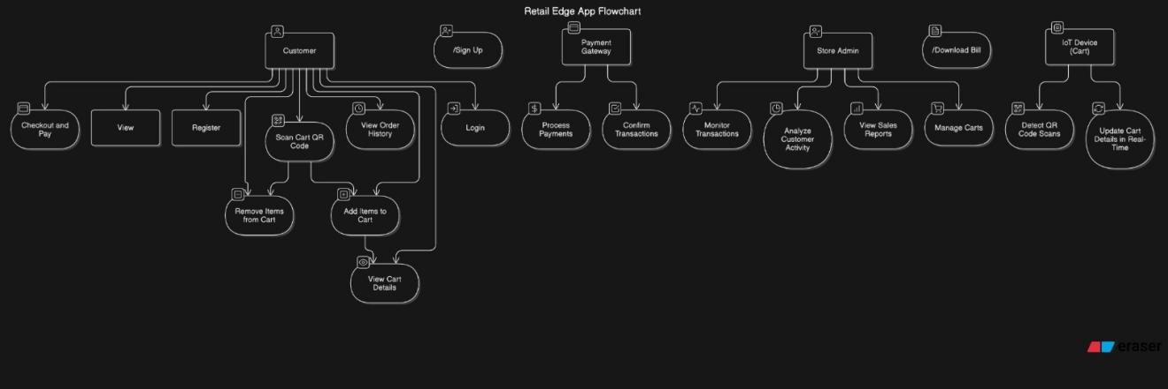

Figure 5.1 Use Case Diagram

### ER Diagram

Below is a conceptual representation of the ER diagram, outlining the entities and their relationships.

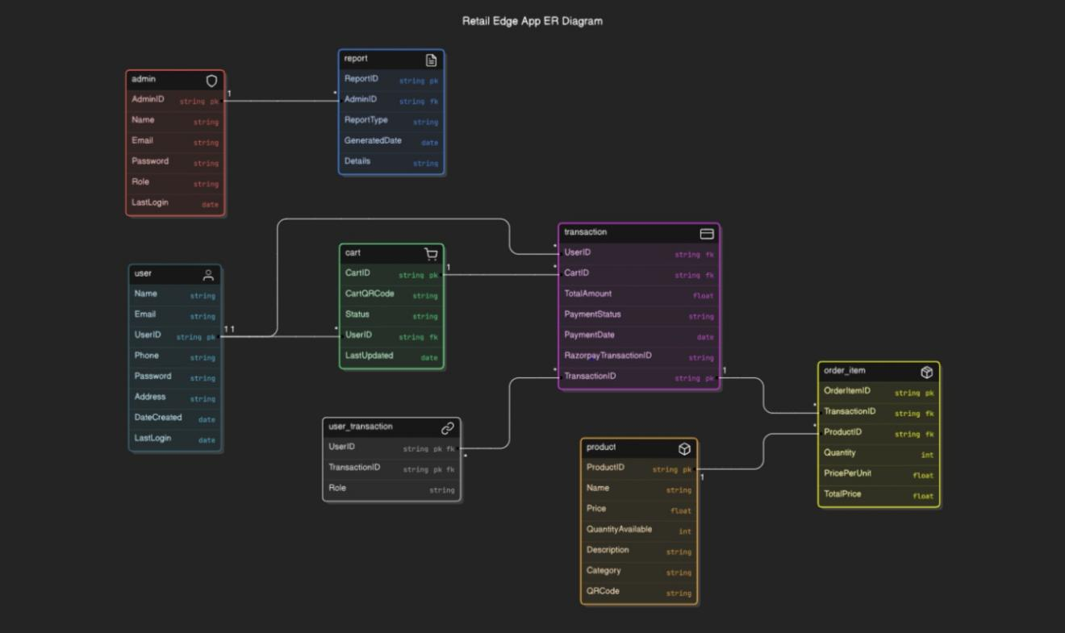

Figure 5.2 ER Diagram

### Data Flow Diagram

Below is a conceptual representation of the data flow diagram, showing the flow of information through the system.

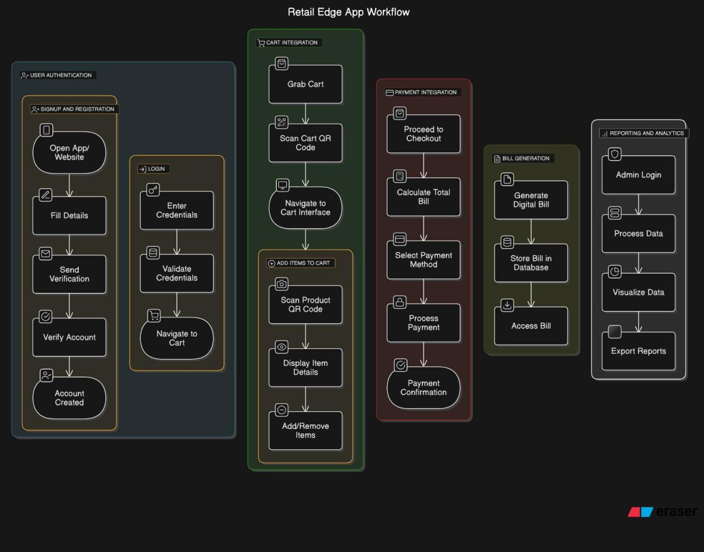

Figure 5.3 Data Flow Diagram

These diagrams provide a clear visualization of the interactions and data flows within the RetailEdge system, ensuring that all actors and processes are accounted for and effectively managed.

**Chapter 6**

**Project Outcomes**

The RetailEdge project is designed to deliver a transformative solution for the retail industry, primarily focusing on enhancing operational efficiency and customer satisfaction. Through its innovative features and user-centric design, the project outcomes can be categorized into technological, operational, and strategic benefits. This section elaborates on the expected outcomes in detail.

### Streamlined Retail Operations

RetailEdge significantly reduces the dependence on manual processes, enhancing the efficiency of retail operations in the following ways:

**Automated Inventory Management:** Store owners will have a centralized system to monitor and manage inventory. The automation of stock updates and notifications for low inventory ensures that products are always in stock, reducing losses due to stock-outs or overstocking.

**Simplified Billing Process:** The automatic bill generation feature eliminates the need for manual calculations, reducing human error and expediting the checkout process. Customers can view itemized bills in real time, ensuring transparency.

**Real-Time Reporting and Analytics:** RetailEdge will provide detailed reports on sales trends, inventory usage, and customer purchasing behavior. These insights enable data-driven decision-making for pricing, stocking, and promotional strategies.

### Enhanced Customer Experience

The project outcomes are designed to elevate the customer shopping experience by providing a seamless, intuitive, and time-efficient system:

**Self-Checkout System:** The self-checkout feature minimizes wait times, giving customers more control over their shopping journey. By using their own devices or store-provided terminals, customers can add products to their cart, make payments, and exit the store without delays.

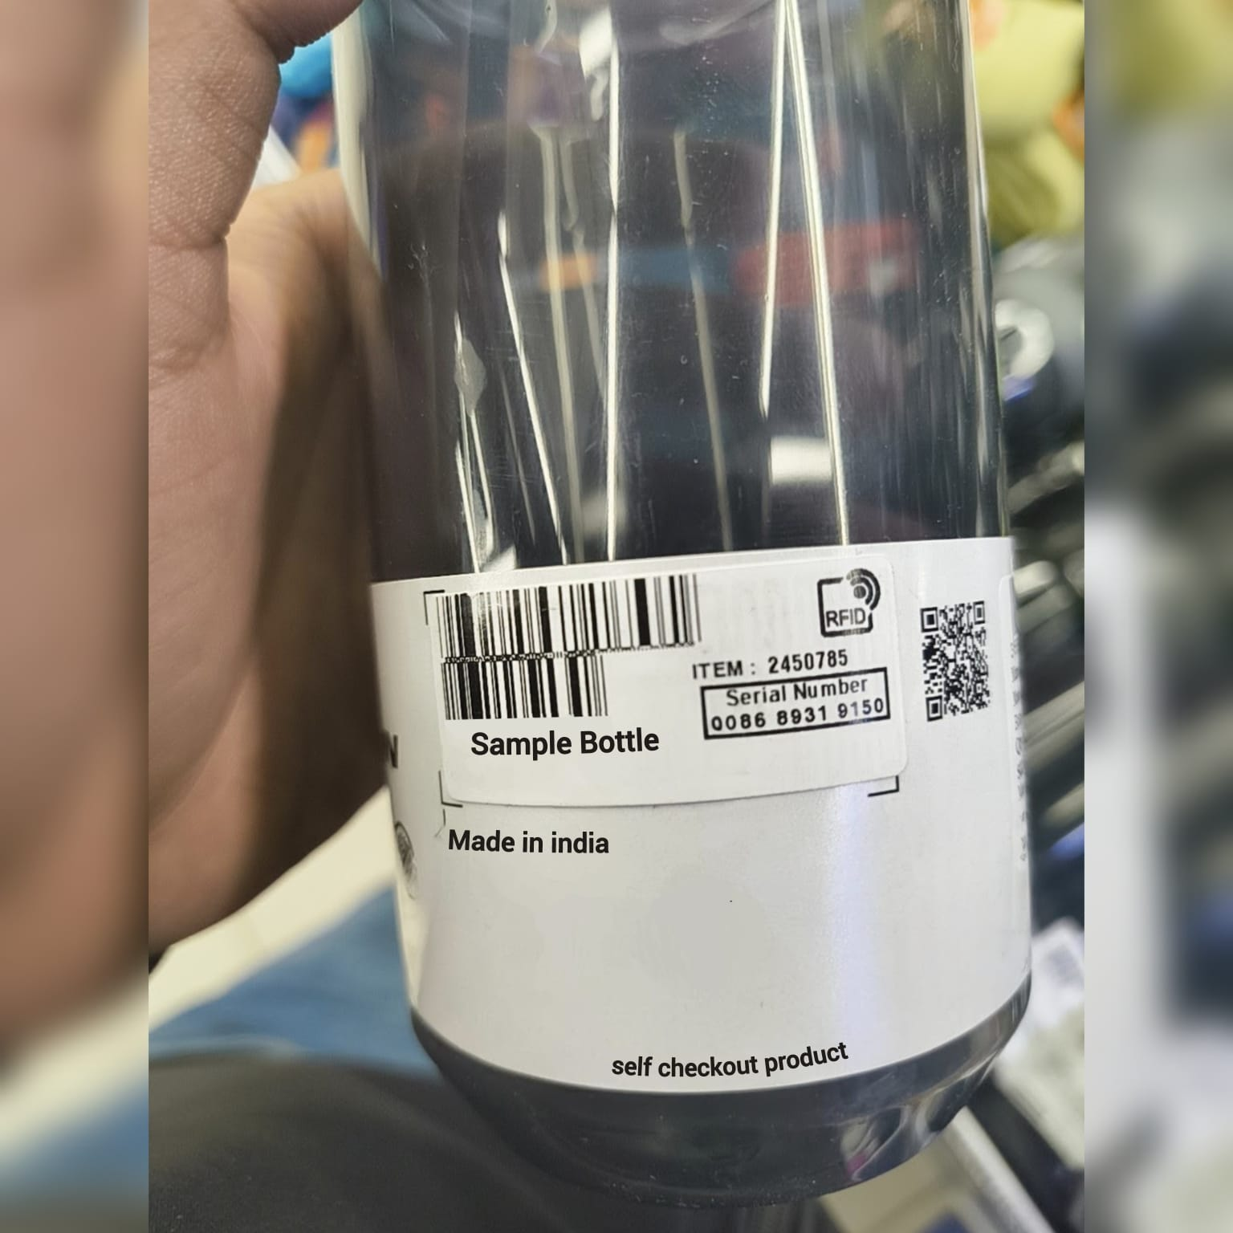

Figure 6.1 RFID

**User-Friendly Interface:** Customers will benefit from a simple, intuitive design that makes navigation through product categories easy. The app’s responsive design ensures it functions smoothly across devices, whether on mobile, tablets, or desktops.

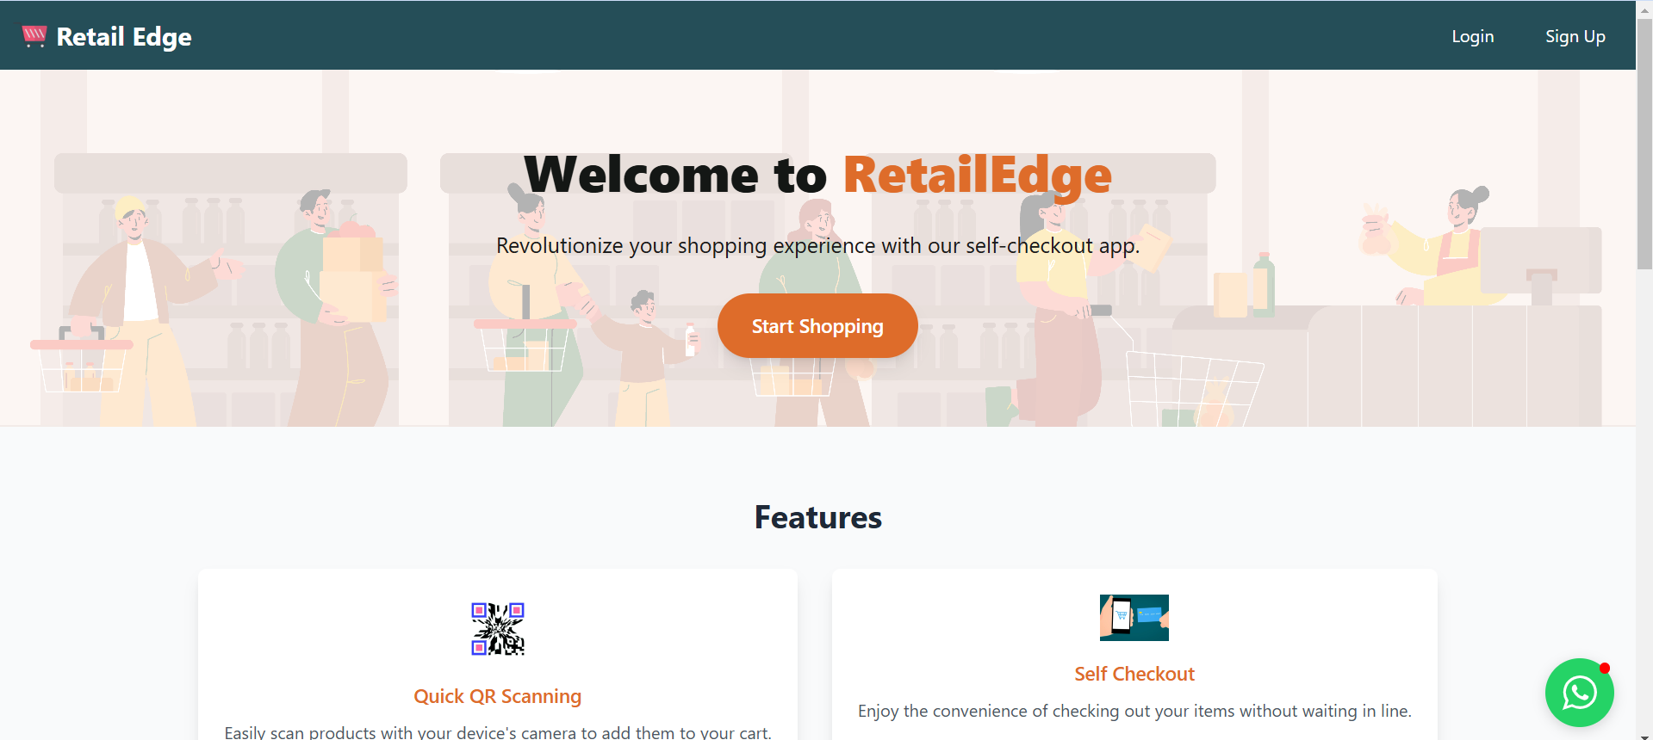

Figure 6.2 Home Page

**Secure and Diverse Payment Options:** The integration of secure payment gateways such as PayPal or Razorpay allows customers to pay using multiple methods, ensuring safety and convenience.

Figure 6.3 Payment Gateway

### Improved Business Decision-Making

RetailEdge will empower store owners with tools and insights to make informed decisions:

**Sales Data Insights:** RetailEdge provides store owners with comprehensive analytics about daily sales, peak shopping times, and top-selling products. These insights can be used to optimize product placement, plan promotions, and introduce loyalty programs.

**Customer Behavior Analysis:** Understanding purchasing patterns will enable personalized marketing strategies. For instance, store owners can offer targeted discounts or recommendations based on customer preferences.

**Cost Savings:** By automating repetitive tasks like billing and inventory management, store owners can reduce labor costs and allocate resources more effectively.

### Scalability and Flexibility

The application is built using Spring Boot, ensuring scalability for businesses of all sizes, from small grocery stores to large supermarkets.

**Adaptability to Business Models:** RetailEdge can cater to a wide variety of retail businesses, including canteens, convenience stores, and large supermarkets.

**Customizable Features:** As businesses grow, the platform can be upgraded to include advanced features such as loyalty programs, marketing tools, and integration with third-party logistics systems.

### Future-Ready Innovations

One of the key outcomes of the project is its preparation for future advancements in retail technology:

**Smart Racks:** By integrating smart racks, stores will benefit from real-time stock tracking. These racks will use sensors to automatically update inventory levels, enhancing accuracy and reducing manual input errors.

**Smart Carts:** Smart carts will allow customers to scan products as they shop, creating a seamless and interactive shopping experience. This upgrade will complement the self-checkout feature, making the process even faster.

### Increased Customer Retention and Loyalty

A combination of streamlined operations and enhanced user experience is expected to improve customer retention:

**Faster Service:** Reduced wait times and a smooth checkout experience will leave a positive impression on customers, encouraging repeat visits.

**Trust and Security:** Secure payment gateways and transparent billing will build customer trust, making them more likely to return.

**Engagement Through Analytics:** Store owners can use insights from the platform to engage customers with personalized offers and rewards, fostering loyalty.

### Economic and Environmental Impact

RetailEdge is designed to create both economic and environmental benefits:

**Economic Benefits:** By reducing errors, minimizing waste, and automating repetitive tasks, RetailEdge will help businesses cut costs and increase profitability.

**Environmental Sustainability:** Digital invoices and receipts will reduce paper usage, contributing to environmental conservation. Automated inventory management can also minimize waste by tracking product expiration dates.

These project outcomes underline the transformative impact RetailEdge aims to have on the retail industry. By addressing critical operational challenges and enhancing the customer experience, RetailEdge provides a comprehensive solution that modernizes retail management and drives business growth. Through continuous innovation and user-centric design, RetailEdge is poised to set new standards in retail technology.

**Technological Advancement for the Retail Industry**

RetailEdge positions itself as a technological innovation that modernizes traditional retail practices. It bridges the gap between physical retail and e-commerce by offering a tech-driven yet accessible solution to small and medium-sized businesses.

### Ease of Adoption

RetailEdge is designed to require minimal technical expertise for its operation, making it accessible to traditional retailers who are less tech-savvy. The system’s user-friendly interface and comprehensive support services ensure that businesses can quickly adopt and integrate RetailEdge into their operations without extensive training or technical know-how. This ease of adoption facilitates a smooth transition from manual processes to automated systems, enhancing operational efficiency and reducing the learning curve for staff.

### Pathway for Further Innovation

The integration of smart technologies like IoT-enabled racks and carts opens avenues for further innovation, ensuring that the platform evolves alongside technological advancements. RetailEdge’s modular design allows for easy integration of new technologies and features, enabling businesses to stay ahead of industry trends and continuously improve their operations. By adopting these innovations, RetailEdge positions itself as a future-ready solution, capable of adapting to the evolving needs of the retail industry.

**Chapter 7**

**References**

**Books**

[1] Laudon, K. C., & Laudon, J. P. (2020). *Management Information Systems: Managing the Digital Firm*. Pearson Education.

[2]Tanenbaum, A. S., & Van Steen, M. (2006). *Distributed Systems: Principles and Paradigms*. Pearson Prentice Hall.

[3]Sommerville, I. (2015). *Software Engineering* (10th ed.). Pearson.

**Journals and Articles**

[4]Kumar, R., & Suresh, M. (2018). "Evolving trends in retail technology and its impact on consumer behavior." *International Journal of Retail & Distribution Management*, 46(6), 567–588.

[5]Smith, J. (2021). "The Role of Cloud Computing in Small Business Retail." *Journal of Business & Cloud Integration*, 12(3), 134–142.

**Web Articles**

[6]Stripe. (2024). "Integration Guide for Secure Online Payments." Retrieved from <https://stripe.com/docs>

[7]Google Developers. (2024). "Building Progressive Web Applications (PWAs)." Retrieved from <https://developers.google.com/web/progressive-web-apps>

[8]Spring Boot Official Documentation. (2024). "Building RESTful Web Services with Spring Boot." Retrieved from <https://spring.io/guides>

**Reports and Case Studies**

[9]Statista. (2024). "Global Retail Technology Market Size and Growth Trends." Retrieved from [https://www.statista.com](https://www.statista.com/)

[10]Deloitte. (2023). *The Future of Retail: Transforming Through Technology*.

**Standards and Guidelines**

[11]PCI Security Standards Council. (2024). "PCI DSS Requirements and Security Assessment Procedures." Retrieved from [https://www.pcisecuritystandards.org](https://www.pcisecuritystandards.org/)

[12]OWASP. (2024). "OWASP Top Ten: Best Practices for Web Application Security." Retrieved from [https://owasp.org](https://owasp.org/)

**Research Papers**

[13]Singh, R., & Sharma, A. (2020). "The Impact of IoT on Retail: From Smart Shelves to Connected Shopping Carts." *Journal of IoT and Emerging Technologies*, 5(2), 89–101.

[14]Gupta, V., & Arora, P. (2019). "Predictive Analytics in Retail: Transforming Data into Business Value." *International Journal of Data Science and Analytics*, 7(4), 243–256.

**Additional References**

[15]AWS Documentation. (2024). "Deploying Scalable Applications with AWS." Retrieved from <https://aws.amazon.com/documentation>

[16]Nielsen Norman Group. (2024). "Best Practices in Web Usability." Retrieved from [https://www.nngroup.com](https://www.nngroup.com/)